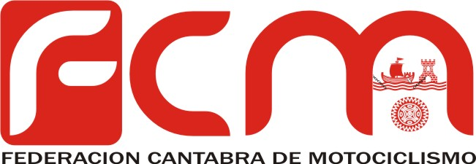

CAMPEONATO REGIONAL DE TODO TERRENO 2015

15/03/2015 | ZALLA | FCM | ENDURO
12/04/2015 | ELGOIBAR | FVM | ENDURO
24/05/2015 | MUNITIBAR | FVM | ENDURO
17/05/2015 | AGUILAR | FMCL | ENDURO
23/05/2015 | MUNITIBAR | FVM | ENDURO
06/06/2015 | SAN SALVADOR | FCM | S. ENDURO
27/06/2015 | MONTE | FCM | S. ENDURO
25/07/2015 | IBIO | FCM | ENDURO
13/09/2015 | POTES | FCM | S. ENDURO
13/12/2015 | SAN SALVADOR | FCM | S. ENDURO
SUSPENDIDA | AGUILAR | FCM | CX

