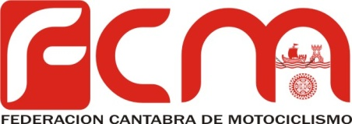

CAMPEONATO MX CLASICAS 2017

SAN SALVADOR | 12/03/2017 | M.C. SAN SALVADOR
GUARNIZO | 6/05/2017 | FCM
NOJA | 10/06/2017 | MX NOJA
SAN SALVADOR | 9/07/2017 | FCM
SAN SALVADOR | 26/27/08/17 | FCM
GUARNIZO | 07/10/2017 | M.C. RJ SPORT
CABEZON | 14/10/2017 | MC LAS ARENAS

